TASK-1
CPU Power connector
CPU Socket

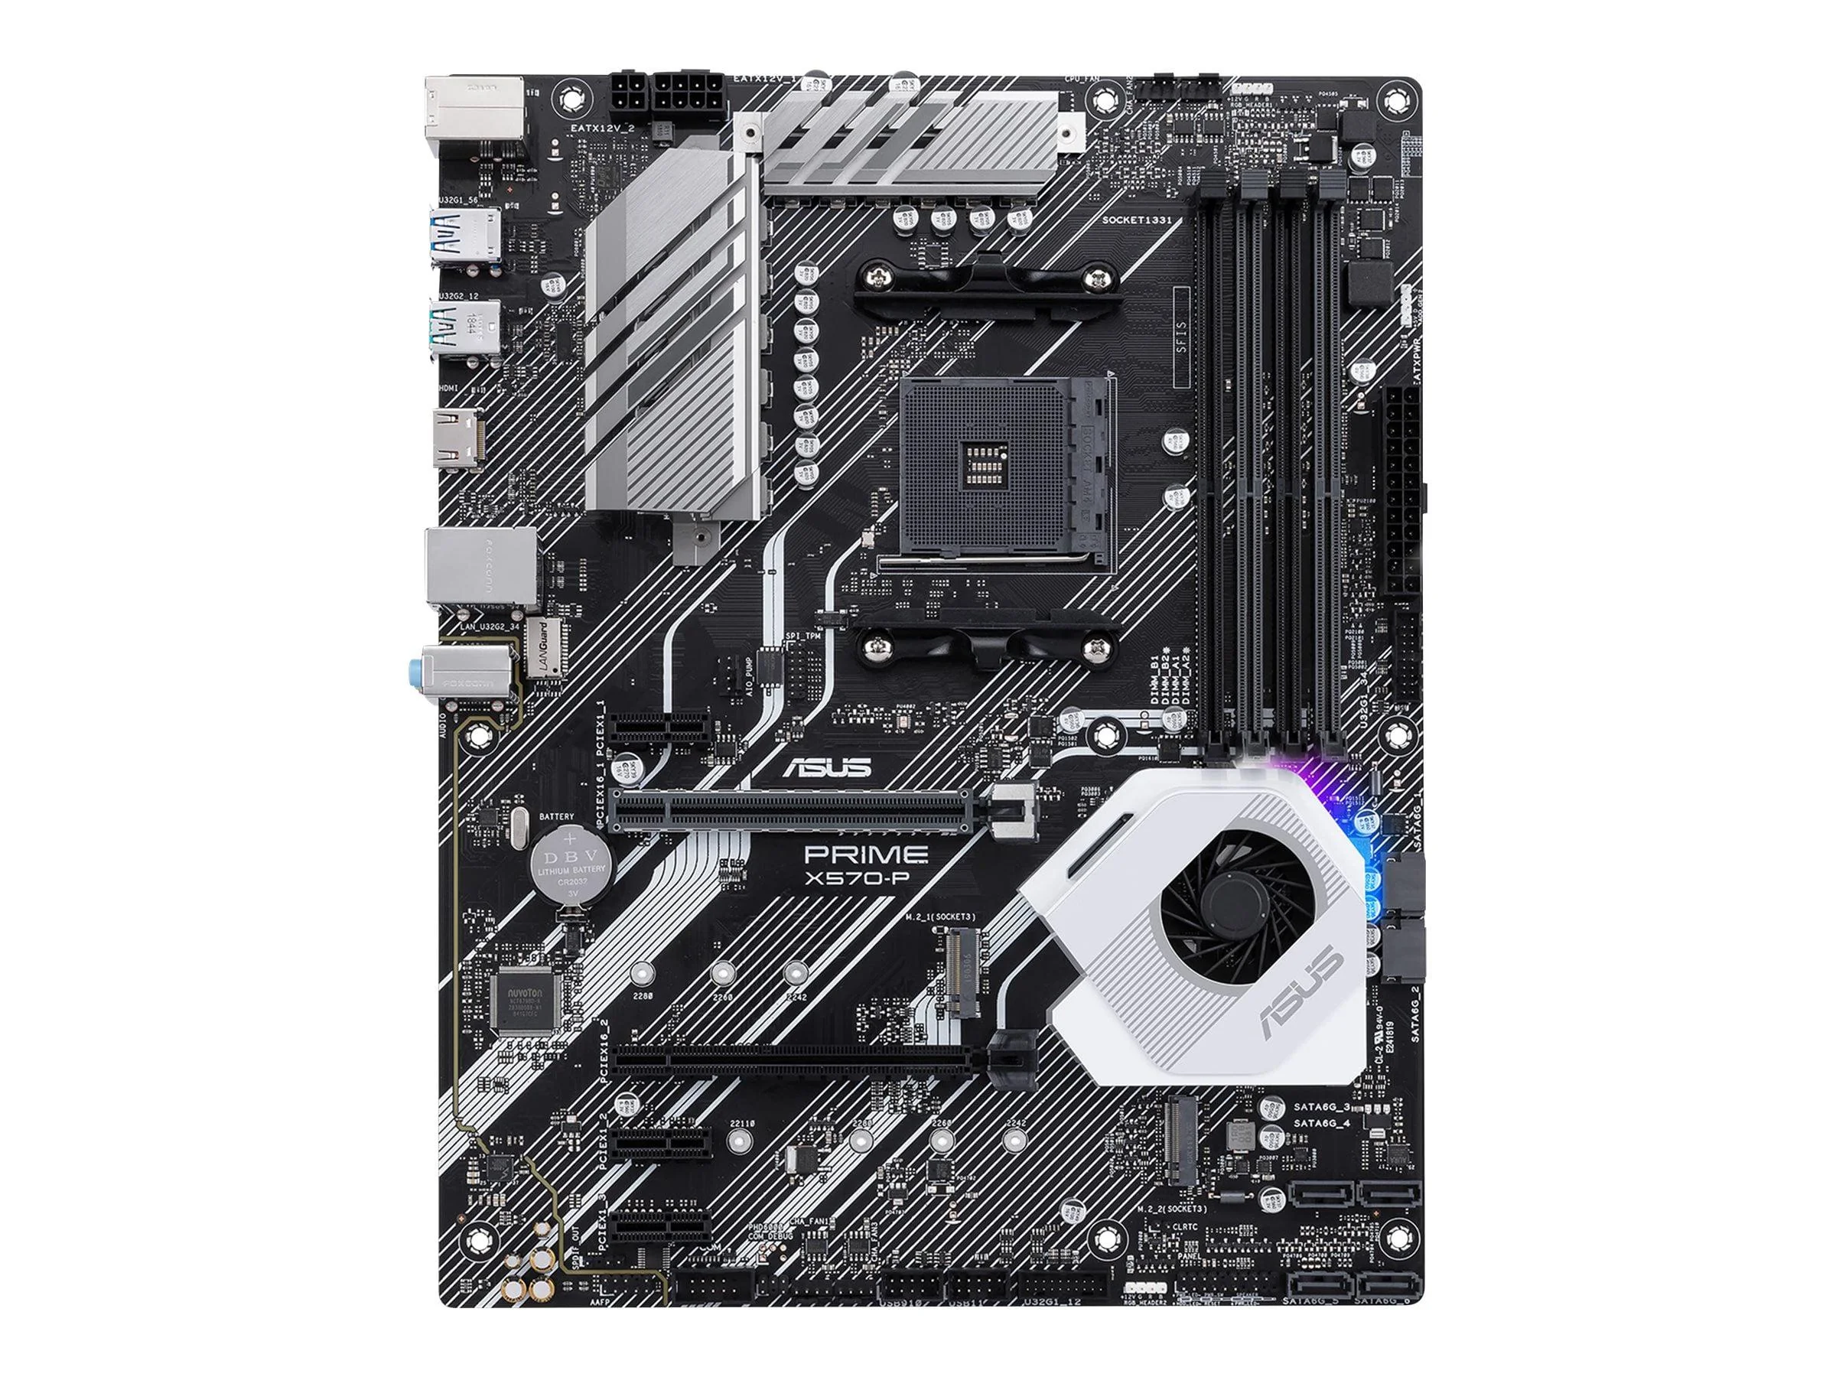
Motherboard Power Connector
M.2 SSD Slot
USB headers
SATA Port
PCIe slots
RAM

Task-2

CPU Socket Manufacturer Compatible CPU Example
LGA1151 Intel Intel Core i7-9700k
AM4 AMD AMD Ryzen 5 5600
LGA1200 Intel Intel Core i5-10600k

Task-3

CPU
The CPU (Central Processing Unit) is the main processor of the computer. It executes instructions, performs calculations, and controls the tasks needed to run programs

Chipset
The chipset is a group of controllers on the motherboard that helps the CPU communicate with other hardware, such as USB devices, storage drives, and other components. It manages the flow of data between these parts.

How they work together with Spotify
When you open Spotify, the CPU processes the instructions needed to start the application and load your music. The chipset helps coordinate communication between the CPU, storage device where Spotify is installed, RAM, and audio hardware. Together, they allow Spotify to load quickly, retrieve music data, and send the audio to your speakers or headphones.

Task-4
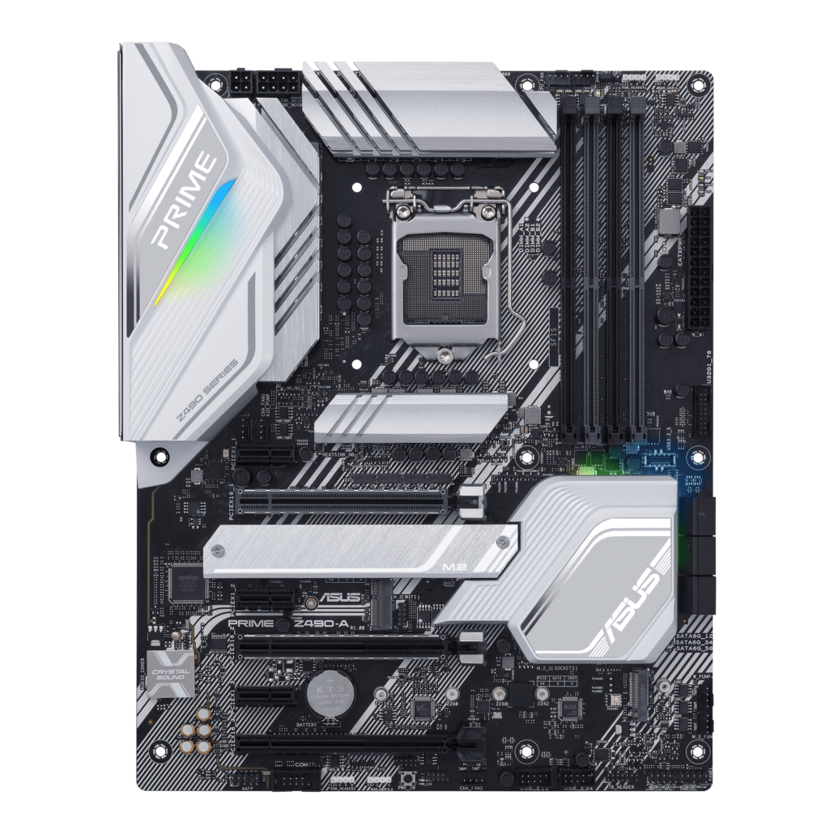
CPU Socket
Ram Slot
Sata Port
PCIe Slot
M.2 SSD Slot

